https://techlogon.com/how-to-fix-a-cannot-download-the-information-you-requested-error-message-on-hyperlinks/:

’Cannot Download the Information You Requested’ Fix (techlogon.com)
Last Updated on March 17, 2019
The ‘Cannot download the information you requested’ error message may appear when you try to open a hyperlink (website link) from within a Microsoft Office program.
Hyperlinks are often included in Excel spreadsheets, Word documents and Outlook emails – in some cases the error message may appear when you click the hyperlink, instead of it opening the website in your default web browser.
Note: similar error messages may be caused by other issues e.g. the hyperlink is invalid – copy and paste it into a web browser to see if it opens the webpage directly.
Contents
Why Can’t It Download the Information 2
1. If the hyperlink is to an encrypted (secure) https:// webpage 2
2. A known issue with Office document hyperlink 3
3. If you have IE10 or earlier 4
Conclusion 4

Why Can’t It Download the Information?
There are several possible causes, each with their own solution. So, let’s consider each in turn:

1. If the hyperlink is to an encrypted (secure) https:// webpage
It is possible that the webpage has set a ‘Pragma: no-cache’ header behind the scenes – this asks IE not to save the webpage to IE’s cache.
However, in order the hyperlink to download the webpage, it does have to be saved to IE’s cache. If the webpage specifically asks IE not to do this and IE is set to not save encrypted pages to disk, the download will fail, and you’ll see the error message.
In this scenario, some hyperlinks may work ok (because the website has not set a ‘Pragma: no-cache’ header or they are http) while others will not work.
To fix this:
- Open IE and click on Tools / Internet Options / Advanced then scroll down to the Security settings and untick the box for ‘Do not save encrypted pages to disk’ as shown below:
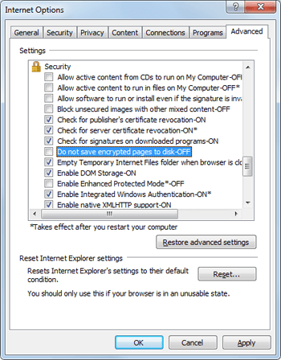
- Now click OK, then close IE and restart the computer – hopefully that problem should now be fixed.

2. A known issue with Office document hyperlink
The ‘Cannot download the information you requested’ error message may appear in certain circumstances if Internet Explorer is not your default web browser. Microsoft have a help page about this issue – it’s for a slightly different error message but the causes and the registry fix are the same.
To fix this:
- Click Start, type regedit in the search box, then click on the regedit.exe program to open it.
- In Registry Editor, browse to one of the following subkeys (create the key if it does not exist):
For a 32 Bit version of Office on 64 bit Windows:
HKLM\SOFTWARE\Wow6432Node\Microsoft\Office\9.0\Common\Internet
For a 32 Bit version of Office on 32 bit Windows Or for a 64 Bit version of Office on 64 bit Windows:
HKEY_LOCAL_MACHINE\SOFTWARE\Microsoft\Office\9.0\Common\Internet
- Make sure the Internet subkey is selected. On the Edit menu, point to New, and then click DWORD Value. Add the following registry value:
Value Name: ForceShellExecute
- Double-click ForceShellExecute, and then set the Value data to 1. Click OK.
- On the Registry menu, click Exit.

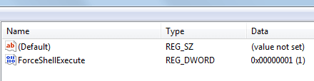
New registry value added
Note: Microsoft advice is to add ForceShellExecute to the ..Office\9.0\Common\Internet subkey path and that should work for most people.
But if it doesn’t, you may need to add it to the Internet subkey of your actual Office build number instead i.e. to one of the following, depending which version of Office you have:
..\Office\16.0\Common\Internet for Office 2016
..\Office\15.0\Common\Internet for Office 2013
..\Office\14.0\Common\Internet for Office 2010
..\Office\12.0\Common\Internet for Office 2007
..\Office\11.0\Common\Internet for Office 2003

3. If you have IE10 or earlier
I came across this issue on older versions of Internet Explorer whilst testing how to work offline in Chrome. The cause is an odd one – regardless of whether or not you ever use it, if Internet Explorer 10 (or earlier) is set to Work Offline then hyperlinks fail to open and the error message is displayed e.g.
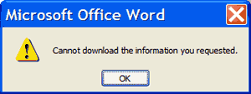
If you use Chrome or Firefox etc as your default web browser (and hyperlinks normally open directly in that browser) you might think that IE settings are irrelevant. However, this isn’t the case – it is likely that the Windows file type of ‘URL’ is still associated with IE.
Therefore, if Internet Explorer is set to Work Offline, the hyperlink can’t be opened (as Windows still thinks you have no internet access i.e. are working offline) – even though your default browser is online and you can open the website fine if you copy and paste the URL link into your browser…
To fix this:
- Open IE and click on Tools in the Command Bar then click on ‘Work Offline’ to untick it – hyperlinks should now open in your default web browser.
- OR
- Open IE and click on ‘File’ in the Menu Bar (if Menu Bar is hidden, press ALT to display it) then click on ‘Work Offline’ to untick it – hyperlinks should now open in your default web browser.
Note: Work Offline was removed from Internet Explorer 11 so this is not an issue in Windows 10, Windows 8 or Windows 7 SP1 because they all have IE11 installed, not IE10 or earlier.

Conclusion
The ‘Cannot download the information you requested’ error message on hyperlinks in Microsoft Office products like Excel and Word can be caused by several issues, mostly relating to Internet Explorer.
It is unusual in that, even if IE is not your default browser, IE settings can still prevent hyperlinks from opening.
However, the potential solutions are relatively easy and worth investigating before trying more complex fixes such as repairing MS Office or switching to a new user account.

